Task on Load balancers:
1) Configure Classic Load balancer.
Steps to Configure Classic Load Balancer
1. Navigate to EC2 Dashboard
- Open AWS Management Console.
- Go to the EC2 service.
- Select “Load Balancers” from the sidebar, then click “Create Load Balancer”.
2. Select Classic Load Balancer
- Choose “Classic Load Balancer” (not Application or Network).
- Click on “Create” under Classic Load Balancer.
3. Configure Basic Settings
- Enter a name for your Load Balancer.
- Select the relevant VPC.
- Choose at least two subnets in different availability zones for high availability.
- Assign an optional tag if needed.
4. Configure Listeners
- By default, HTTP (port 80) is set up.
- Modify or add listeners for HTTP, HTTPS, or TCP as per your application needs (e.g., HTTP:80→80).
- For HTTPS, upload or select an SSL certificate.
5. Assign Security Groups
- Assign an existing or new security group that allows inbound traffic on the listener ports (e.g., 80, 443).
- Ensure EC2 instances’ security groups allow traffic from the load balancer subnet group.
6. Configure Health Checks
- Specify a ping protocol and port (e.g., HTTP:80).
- Enter the ping path (e.g.,/index.html or /health).
- Set thresholds for healthy/unhealthy check counts, interval, and timeout.
7. Register Instances
- Select the EC2 instances you want to balance traffic to.
- Add them to the load balancer and review their status.
8. Review and Create
- Review all settings.
- Click “Create” to launch your Classic Load Balancer.
9. Test the Load Balancer
- Note the DNS name provided (e.g., myCLB-1234567890.ap-south-1.elb.amazonaws.com).
- Access this DNS endpoint in a web browser to verify correct routing to backend instances.
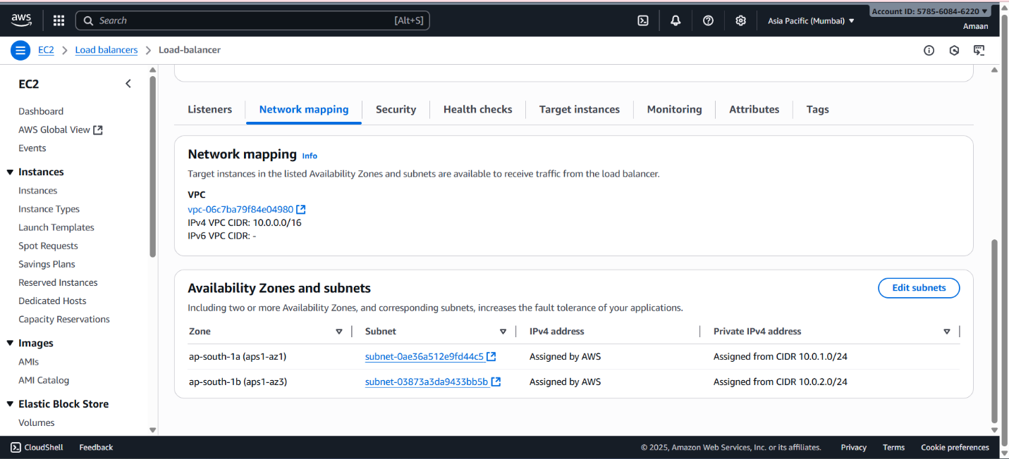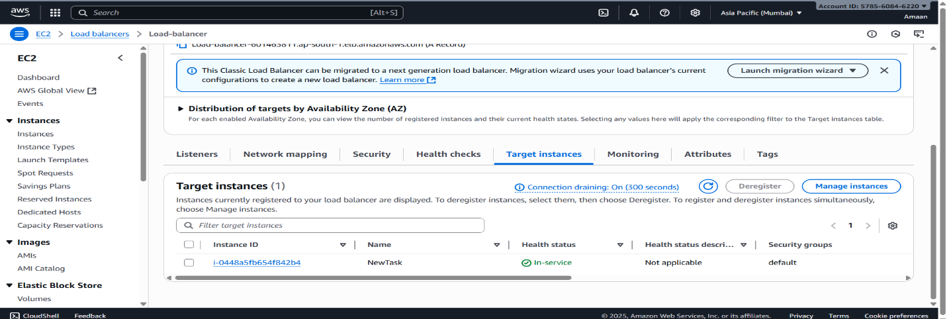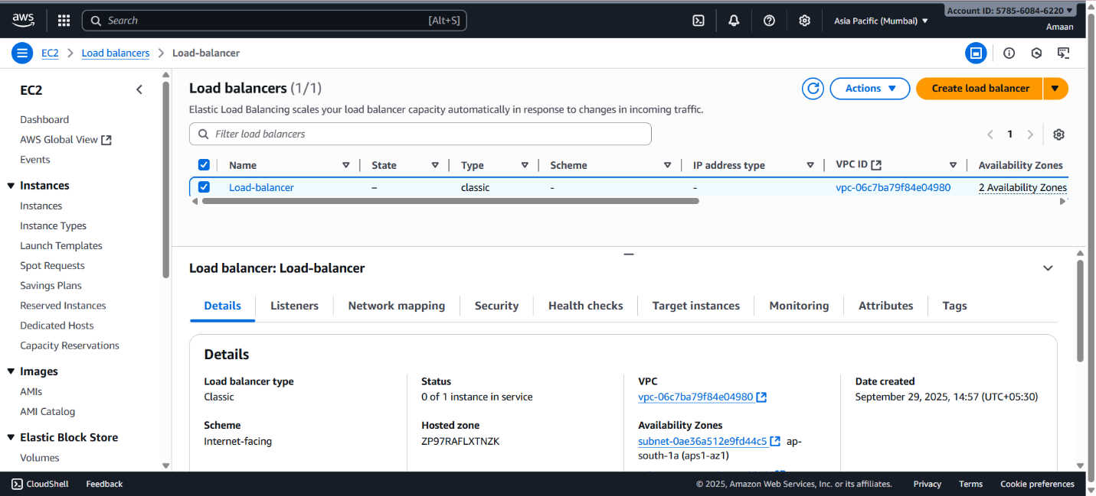

2) Configure Application Load balancer.

To configure an AWS Application Load Balancer (ALB), here is a step-by-step guide:
Step 1: Create a Target Group
- Go to the EC2 Dashboard.
- From the sidebar, select Target Groups.
- Click Create target group.
- Choose target type as Instances.
- Enter a name for the target group.
- Select VPC where your instances run.
- Keep protocol as HTTP and port as 80 (or as per your app).
- Configure health check settings (path, protocol, port).
- Click Next and register your instances by selecting them.
- Click Create target group.
Step 2: Create the Application Load Balancer
- In the EC2 console, go to Load Balancers.
- Click Create Load Balancer, then select Application Load Balancer.
- Enter a name for your ALB.
- Choose Internet-facing for scheme (or Internal if required).
- Select IPv4 for IP address type.
- Select the VPC.
- Choose at least two availability zones and subnets for high availability.
- Assign security group(s) that allow inbound traffic on listener ports (e.g., 80, 443).
Step 3: Configure Listeners
- Add listeners (default is HTTP:80).
- For HTTPS, upload or select an SSL certificate.
- Set the default action to forward to your target group created earlier.
Step 4: Review and Create
- Review all configurations.
- Click Create.
Step 5: Validate and Test
- Wait for the ALB status to become Active.
- Check target group for the registered instances and their health status (should be "healthy").
- Access your ALB DNS name to verify traffic is routed correctly.
This setup ensures your ALB distributes incoming traffic to healthy instances based on the health checks and routing rules. 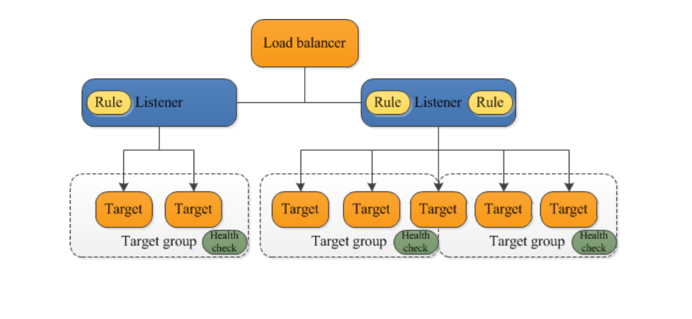
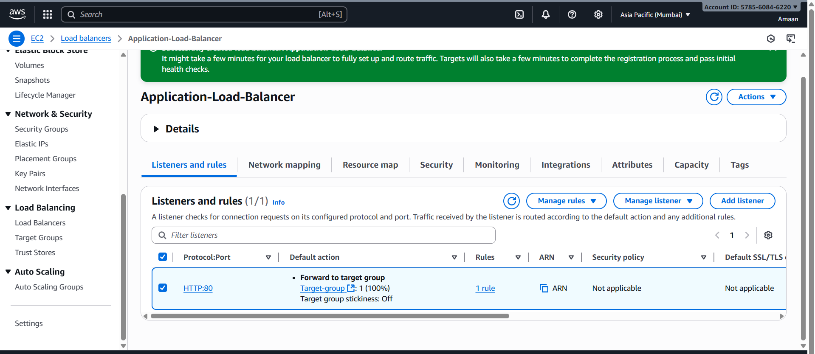
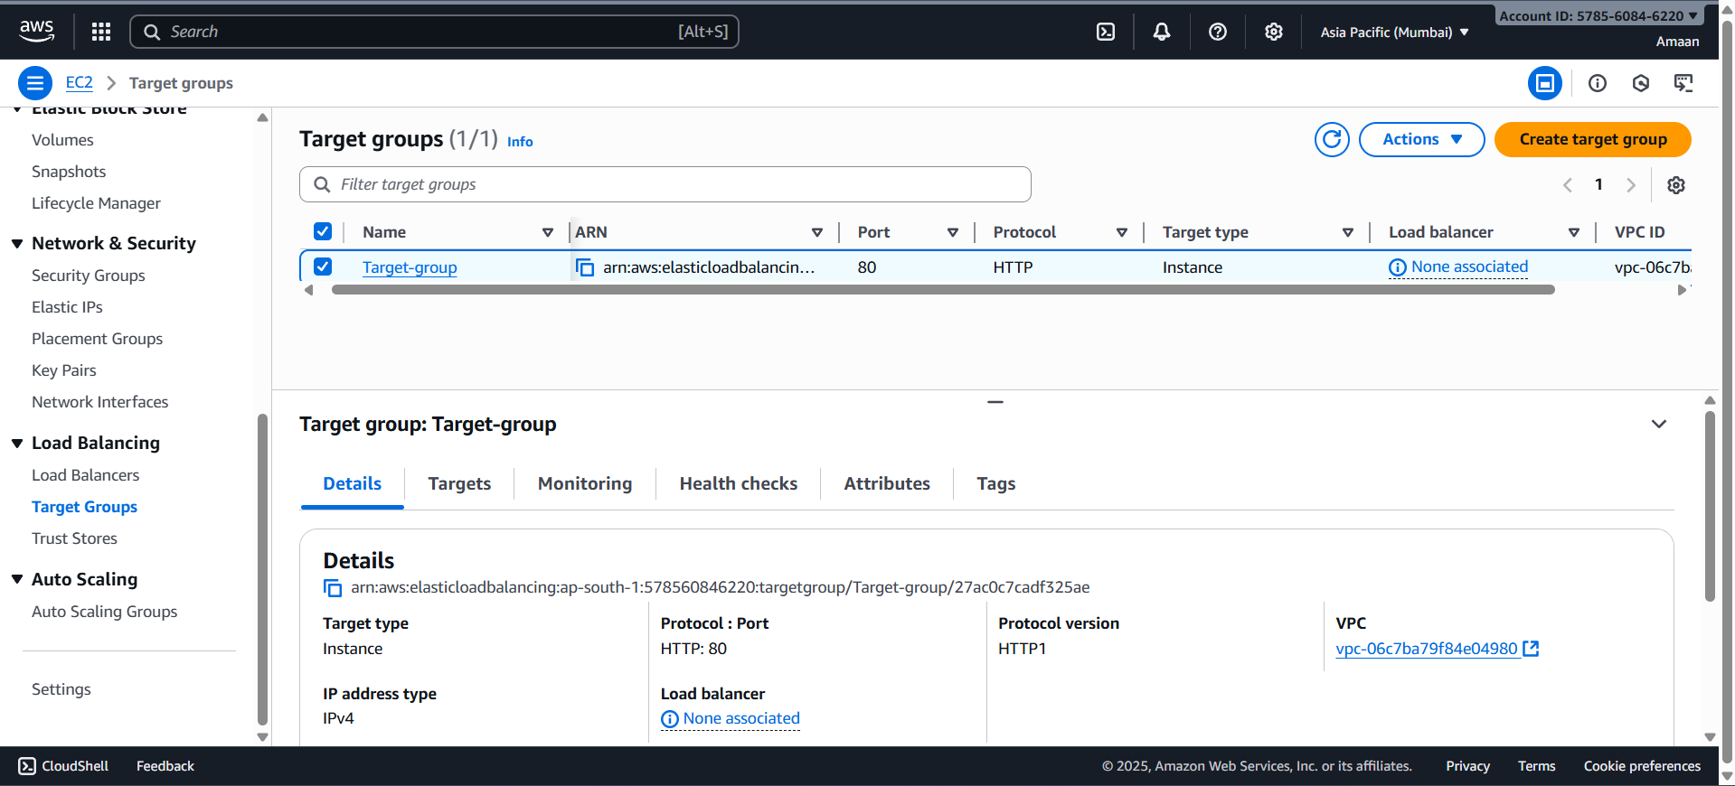

3) Configure Network Load balancer.

Here are the step-by-step instructions to configure an AWS Network Load Balancer (NLB):
Step 1: Create a Target Group
- In the AWS Management Console, go to EC2 service.
- Select Target Groups from the left panel.
- Click Create target group.
- Choose target type (Instance, IP, or Lambda). Usually, choose Instances.
- Enter a name for the target group.
- Select the protocol (TCP, UDP, or TLS) and port your application listens on (e.g., TCP on port 80).
- Choose the VPC where your instances run.
- Configure health check protocol and port (usually TCP).
- Click Next and register your EC2 instances to the target group.
- Click Create target group.
Step 2: Create the Network Load Balancer
- Go to Load Balancers in the EC2 dashboard.
- Click Create Load Balancer.
- Select Network Load Balancer and click Create.
- Provide a name for the NLB.
- Choose scheme: either internet-facing or internal based on use case.
- Select IP address type: IPv4 or Dualstack.
- Select at least two Availability Zones with subnets for redundancy.
- Configure listeners: default is TCP on port 80; add others if needed.
Step 3: Configure Security Groups (if applicable)
- Unlike ALB, NLB does not use security groups directly but your EC2 security groups must allow inbound traffic from client IPs and the NLB.
Step 4: Attach Target Group to Listeners
- For each listener, define default action as forward to the created target group.
Step 5: Review and Create
- Review all settings.
- Click Create Load Balancer.
Step 6: Test and Validate
- Wait for the load balancer to become active.
- Check the target group for the health status of registered instances.
- Access the NLB DNS name and verify traffic forwarding.
This setup allows high-performance TCP/UDP traffic distribution with ultra-low latency, useful for performance-sensitive applications.
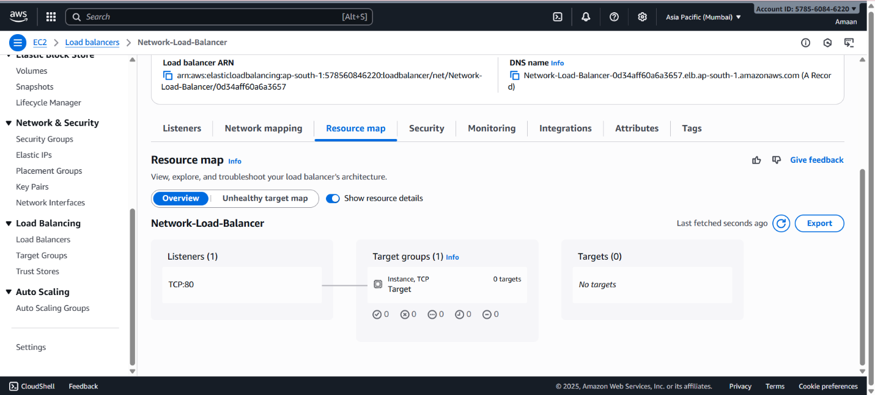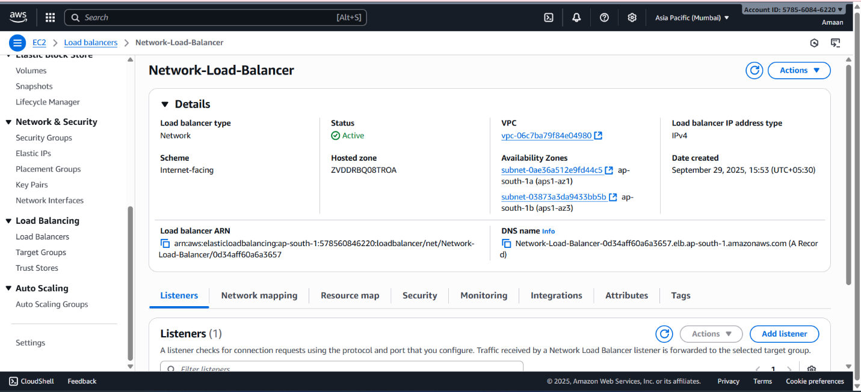

4) Attach SSL for application load balancer.

To attach an SSL certificate to your AWS Application Load Balancer (ALB), follow these steps:
Step 1: Obtain or Import an SSL Certificate
- Use AWS Certificate Manager (ACM) to request or import an SSL certificate in the same AWS region as your ALB.
- You can request a public certificate for your domain (e.g., www.example.com) via ACM or import a third-party certificate into ACM.
Step 2: Add an HTTPS Listener to Your ALB
- Open the AWS Management Console and navigate to EC2 > Load Balancers.
- Select your Application Load Balancer.
- Go to the Listeners tab.
- Click Add listener.
- Choose HTTPS as the protocol and port 443.
- For the default action, select Forward to your target group that serves your application.
Step 3: Configure SSL Certificate on Listener
- Under Default SSL/TLS certificate, select From ACM.
- Choose your SSL certificate from the drop-down list.
- Optionally configure security policies and advanced settings.
Step 4: Save the Listener Configuration
- Click Add to add the new listener.
- Save changes to apply.
Step 5: (Optional) Redirect HTTP to HTTPS
- You can set a rule on the HTTP listener to redirect all HTTP traffic on port 80 to HTTPS on port 443 for better security.
Step 6: Test the Load Balancer
- Access your ALB DNS name with https://.
- The connection should be secured with your SSL certificate.
This process encrypts traffic between clients and the load balancer. The ALB decrypts the traffic and forwards it to the backend instances as configured.
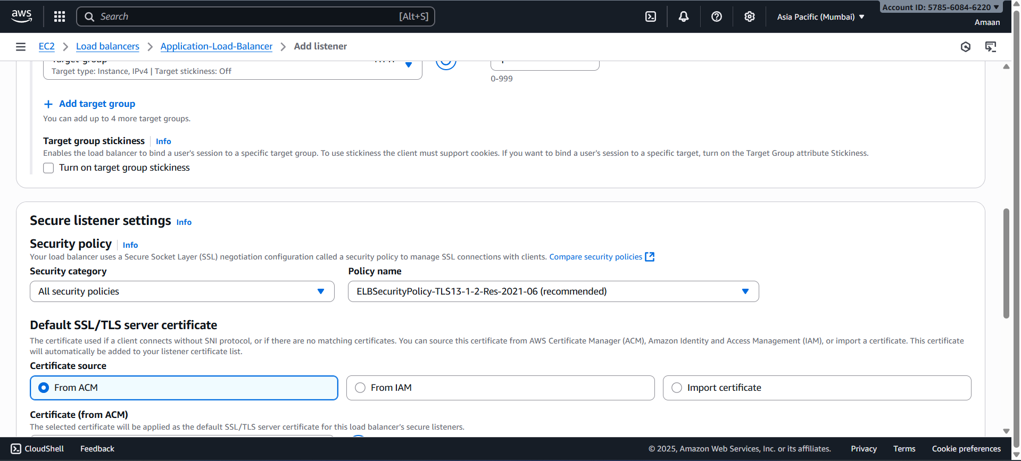

5) Map Application load balancer to R53.

To map an Application Load Balancer (ALB) to a domain using Route 53, follow these steps:
Step 1: Get the ALB DNS Name
- In the AWS Management Console, go to the EC2 service.
- Under Load Balancers, select your ALB.
- Copy the DNS name (e.g., alb-1234567890.ap-south-1.elb.amazonaws.com).
Step 2: Open Route 53 Console
- Navigate to Route 53 in the AWS Console.
- Go to Hosted Zones and select your domain’s hosted zone.
Step 3: Create an Alias Record to the ALB
- Click Create record.
- Set record type to A – IPv4 address.
- Turn Alias on.
- For "Alias to", select Alias to Application and Classic Load Balancer.
- Choose the AWS region where your ALB is deployed.
- In the dropdown, select your ALB by its DNS name.
- Enter the subdomain or leave blank to map the root domain.
- Choose the routing policy (default is simple).
Step 4: Save the Record
- Click Create Records to save.
Step 5: Validate
- Wait for DNS propagation.
- Access your domain name in a browser; it should route traffic to your ALB and backend instances.
This sets up a Route 53 alias record, which is preferred over CNAME for the root domain and provides seamless integration with AWS resources without extra DNS charges.
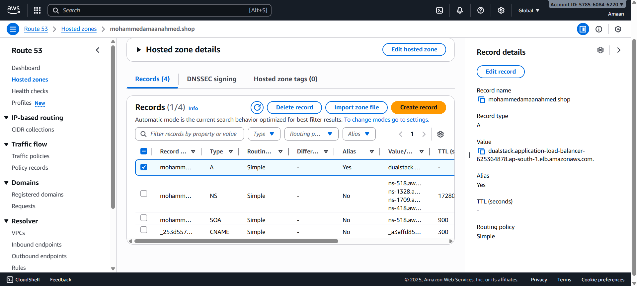

6) Push the application load balancer logs to s3

To push Application Load Balancer (ALB) access logs to an S3 bucket, follow these steps:
Step 1: Create an S3 Bucket
- Open the AWS S3 console.
- Create a new bucket in the same region as your ALB.
- Enable default encryption (SSE-S3) for security (optional but recommended).
Step 2: Attach Bucket Policy for Write Access
- The S3 bucket must have a policy granting permission to the ELB service to write logs.
- Example policy (replace bucket name and account ID):
json
{
"Version": "2012-10-17",
"Statement": [
{
"Effect": "Allow",
"Principal": {
"Service": "logdelivery.elasticloadbalancing.amazonaws.com"
},
"Action": "s3:PutObject",
"Resource": "arn:aws:s3:::your-bucket-name/AWSLogs/your-account-id/*"
}
]
}
- Apply this policy in the S3 bucket permissions.
Step 3: Enable Access Logs on Application Load Balancer
- Go to EC2 console > Load Balancers.
- Select your Application Load Balancer.
- In the Attributes tab, find the Access logs section.
- Enable access logs.
- Specify the S3 bucket name created earlier.
- (Optional) Add a prefix for log file organization.
Step 4: Validate Log Delivery
- After enabling, the ALB validates the bucket permissions by writing a test file.
- Check the S3 bucket for a file named ELBAccessLogTestFile.
- Logs will arrive periodically in folders organized by dates and load balancer.
